What is One Identity Password Manager?
The One Identity Password Manager allows a forgotten iRBS password to be reset using 2 random questions from those entered during the registration process.

Using the One Identity Password Manager Home Menu
- Enter the URL for the Password Manager into your Chrome browser.
https://passwordreset.adfhsc.com.au/pmuser

- Enter your iRBS user name (E.g. {first name}.{last name}@adfhsc.com.au), then select “OK”.
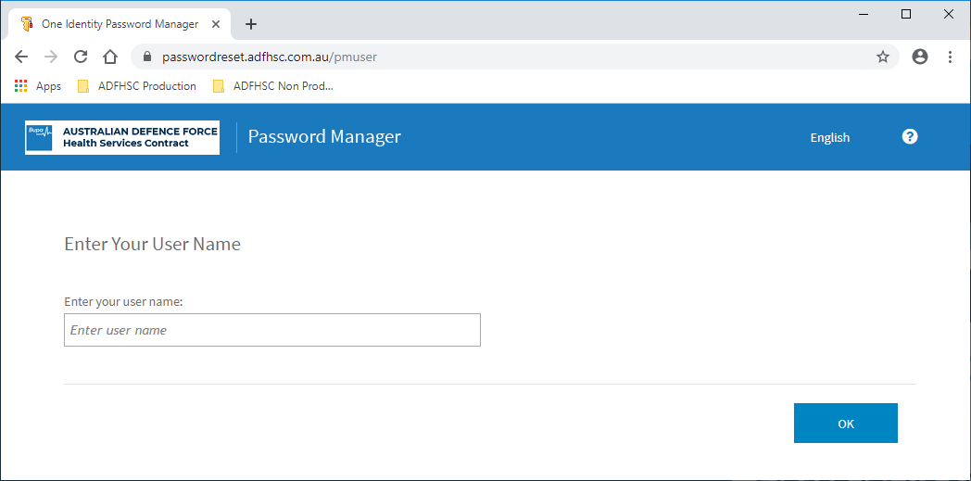

- The Home Menu options for a registered One Identity user are:
  - Manage My Profile with Password Manager, allows
    - the answers to your secret questions to be updated, and
    - the mobile number that receives the code to reset your password can be changed.
  - Reset Password
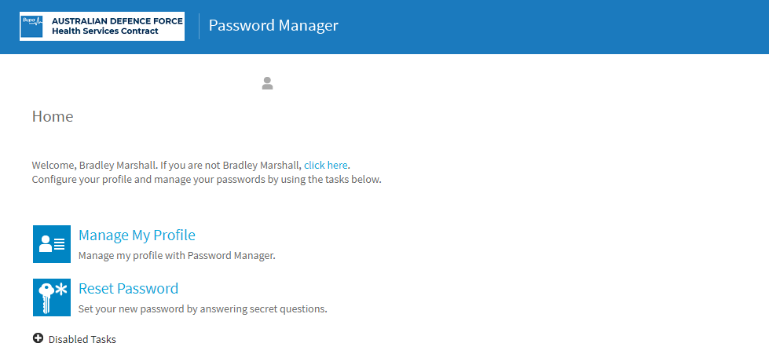

- Select “Reset Password” from the Home Menu.
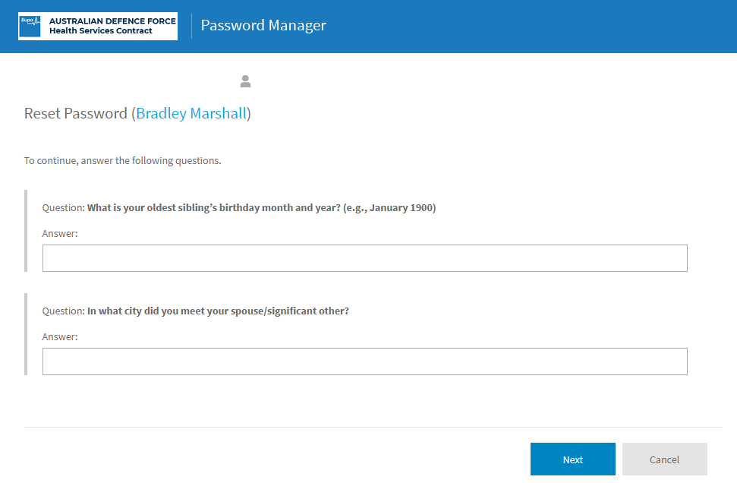

- Enter the answers to the 2 questions, then select “Next”.
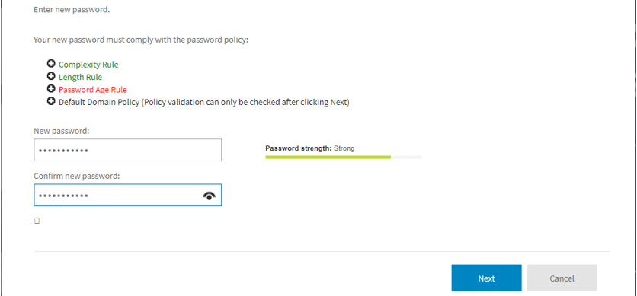

- Enter the New password, confirm the New password, then select “Next”.


- Congratulations, your password was successfully reset.

