What is One Identity Password Manager?
The One Identity Password Manager allows a forgotten iRBS password to be reset using 2 random questions.

To enable this functionality, you need to set an answer against 5 of the available security questions.

Register as a One Identity User
- Enter the URL for the Password Manager into your Chrome browser.
https://passwordreset.adfhsc.com.au/pmuser

- Enter your iRBS user name (E.g. {first name}.{last name}@adfhsc.com.au), then select “OK”.
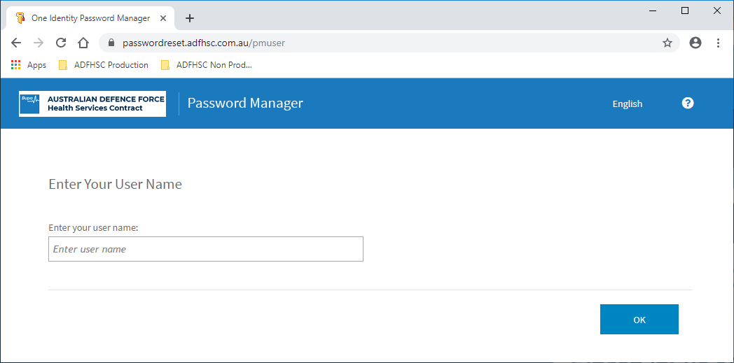

- Select “Register” from the One Identity Password Manager Home Menu.
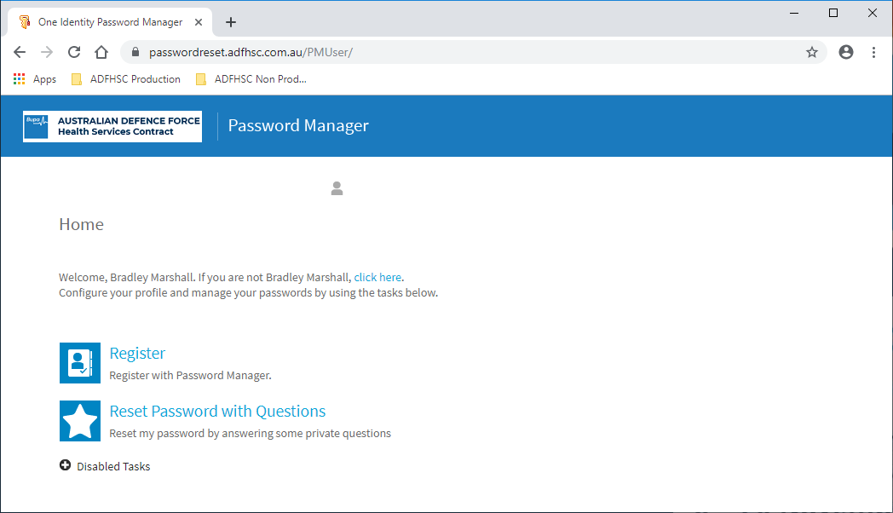

- If your password has expired, you will get an error and you need to do these steps (a & b). Otherwise, your password is valid, and you should continue to step 5.
  - Enter the URL to reset your password into your Chrome browser.
https://fs.adfhsc.com.au/adfs/portal/updatepassword
  - Once the password has been reset, return to step 1.

- Enter your iRBS password, then select “Next”.
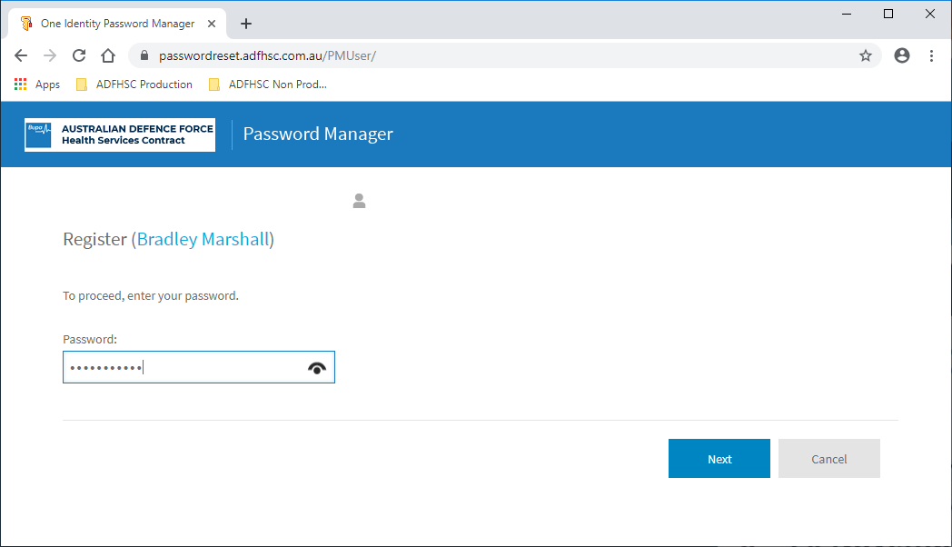

- Enter answers for the required 5 Security Questions.
  - Select a question from the dropdown list.
  - Enter your answer to the selected question (minimum length of 3 characters).
  - Note: to complete all questions you will need to scroll down the window.
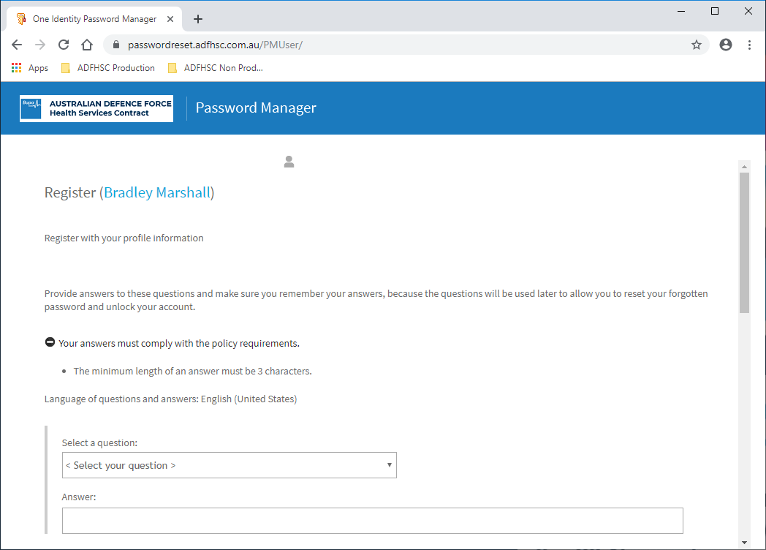

- Select “Next”.
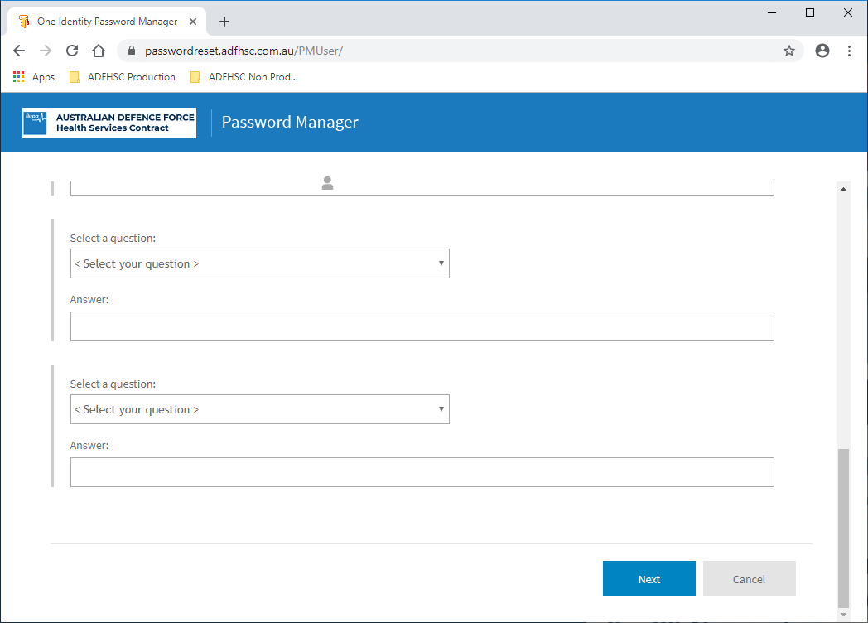

- You have completed the registration process.

